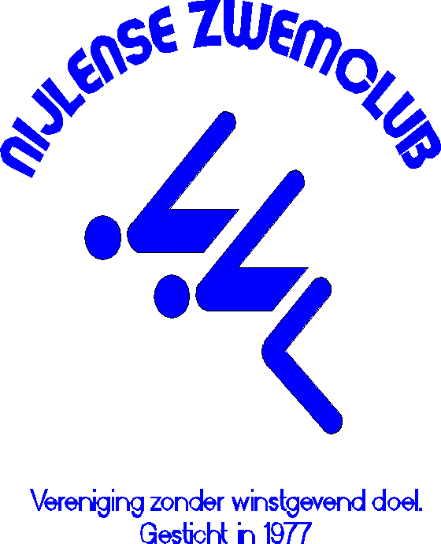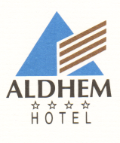

Jagersdreef 1 - 2280 Grobbendonk – Belgium

Tel ++32 14 50.10.01 - Fax ++32 14 50.10.13

Fill in this reservation form and fax it to 0032 14501013 or mail it to info@aldhem.be

19th November – 20th November 2016 Competition

Nijlense zwemclub

Booking before 30th October 2016

Name:……………………………………………………………………………………………………………………………………………………………

Address:………………………………………………………………………………………………………………………………………………………

Postcode:…………………………………………………Town:……………………………………………………………………………………….

Country:……………………………………………………………………………………………………………………………………………………...

E-mail address:………………………………………………………………………………………………………………………………..………..

Tel.:…………………………………………………………..Fax:………………………………………………………………………………………….

***Make a reservation for:***

……Single room(s) € 79.00/night including breakfast, VAT & service charges

……Double room(s) (one large bed) € 92.00/night, including breakfast, VAT & service charges

……Twin room(s) (2 single beds) € 92.00/night, including breakfast, VAT & service charges

……Triple rooms ( 3 single beds) € 129.00/night, including breakfast, VAT & service charges

Number of nights: ………………..

Date of arrival: …………………………………………

Date of departure: ……………………………………….

The above mentioned reduced “Nijlense zwemclub” rates are valid in case of advanced booking and upon availability.

* In order to guarantee your reservation we need the following information about your credit card:

Type:………………….Cardnumber:………………………………………………....Expiry date:…………………Sec Code………….

Name cardholder:……………………………………………………………………………….…………………………………………………

This guarantee is obliged.

Signature:……………………………………………………….

Cancellation conditions:

Till 78h before arrival date: no costs

Less then 78h before date of arrival: the first night will be charged.

Routedescription on [www.aldhem.be](http://www.aldhem.be)